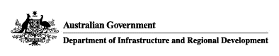

Unrestricted Used Motorcycle Entry

**Entry No.: 812/02**

|  |  |
| --- | --- |
| **Schedule 1 Vehicle Details** | |
| Make : | HARLEY DAVIDSON |
| Model : | V-ROD |
| Model Code : | VRSC |
| Category : | LC |
| First Build Date :  Last Build Date : | 1/1/2001  31/12/2017 |
| Variants: VRSC, VRSCA, VRSCB, VRSCD, VRSCE, VRSCF, VRSCR, VRSCX, VRSCAW, VRSCDX, VRSCSE, VRSCSE2, VRSCDXA. | |
|  | |
| **Schedule 2 Conditions**  **Only vehicles with the features listed below satisfy this entry** | |
| Engine: N/A | |
| Body: N/A | |
| Other: N/A | |
|  | |
| **Schedule 3 Alternative Make and Model** | |
| Entry No: N/A | |

Umesh Shamdasani 18 November 2020

Associate Administrator of Vehicle Standards Issue Date